Synopsis

Medal prediction of country using numerical data

Problem Id: 26

Student Name: Tarun Purohit
University Roll number: 2028880
Section: P
Student Name: Shobhit Rawat
University Roll number: 2028851
Section: P
Student Name: Gaurav Dubey
University Roll number: 2028719
Section: P

- Problem Description:
Design and develop a regression-based machine learning model to predict medals of a country using numerical data using a suitable dataset with athlete count,medal count and year wise data.
The dataset contains the following 15 input features: ID,Name,Age,Height,Weight,Team,Noc,Games,Year,Season,City,Season,,Sport,Event,Medal.

The project should begin with Exploratory Data Analysis (EDA) to analyze feature distributions, correlations, and their relationship with the target variable. Perform data preprocessing including handling missing values, encoding categorical features, and normalization or feature scaling.

We will clean our dataset by imputing the null values of medal columns and remove the columns which are not needed for training our model.

Develop and train suitable regression models to predict medals . Finally, evaluate the trained models using appropriate regression performance metrics such as R2 score and error measures such as MAE, MSE, and analyze the impact of different features on the prediction outcome. The project should demonstrate a complete machine learning pipeline from raw data to model evaluation and interpretation.

- Steps of Implementation:

1. Problem Definition
This step involves clearly defining the objective of the project, which is to predict medals based on various numerical features. Since the output is a numerical value, it is a regression problem under supervised learning. You also identify input variables (features) and the target variable (total_medals). A clear problem definition helps guide model selection and evaluation criteria.

2. Data Collection & Loading
In this step, the dataset is gathered and loaded into the working environment using tools like Pandas. The structure of the dataset is examined, including the number of rows, columns, and data types. Initial checks help ensure the dataset is correctly loaded and ready for analysis. It also helps identify any obvious inconsistencies or issues.

3. Exploratory Data Analysis (EDA)
EDA is performed to understand the data’s structure and patterns. Statistical summaries and visualizations are used to analyze distributions, detect outliers, and observe relationships between features and the target variable. Correlation analysis helps identify which features strongly influence medal number. This step builds intuition and guides preprocessing and model selection.

4. Data Preprocessing
This step prepares the raw data for modeling by cleaning and transforming it. Missing values are handled using appropriate techniques such as mean or mode imputation. Categorical variables are converted into numerical form using methods like One-Hot Encoding. Feature scaling, such as Standardization, ensures all variables are on a comparable scale.

5. Feature & Target Split
The dataset is divided into input features (X) and the target variable (y), which is the house price. This separation is necessary because the model learns patterns from input features to predict the target. It clearly defines what data is used for training versus what is being predicted. Proper splitting ensures organized data flow in later steps.

6. Train-Test Split
The dataset is split into training and testing subsets and the training set is used to build the model, while the test set evaluates its performance on unseen data. This helps detect overfitting and ensures the model generalizes well. It is a crucial step for reliable performance assessment.

7. Model Development
In this step, different regression algorithms such as Linear Regression, Decision Trees, and Random Forest are trained on the data. Each model learns patterns between input features and house prices. Trying multiple models allows comparison of performance and selection of the best one. This step forms the core predictive component of the system.

8. Model Evaluation
The trained model is evaluated using performance metrics like R2 Score, Mean Absolute Error, and Mean Squared Error. These metrics quantify how accurately the model predicts total medals. Evaluation on test data ensures unbiased performance measurement. It helps in comparing models and identifying improvements.

9. Model Optimization
Model performance is improved by tuning hyperparameters using techniques like grid search or cross-validation. This process finds the best combination of model settings for optimal results. Optimization reduces errors and enhances generalization ability. It ensures the model performs well on unseen data.
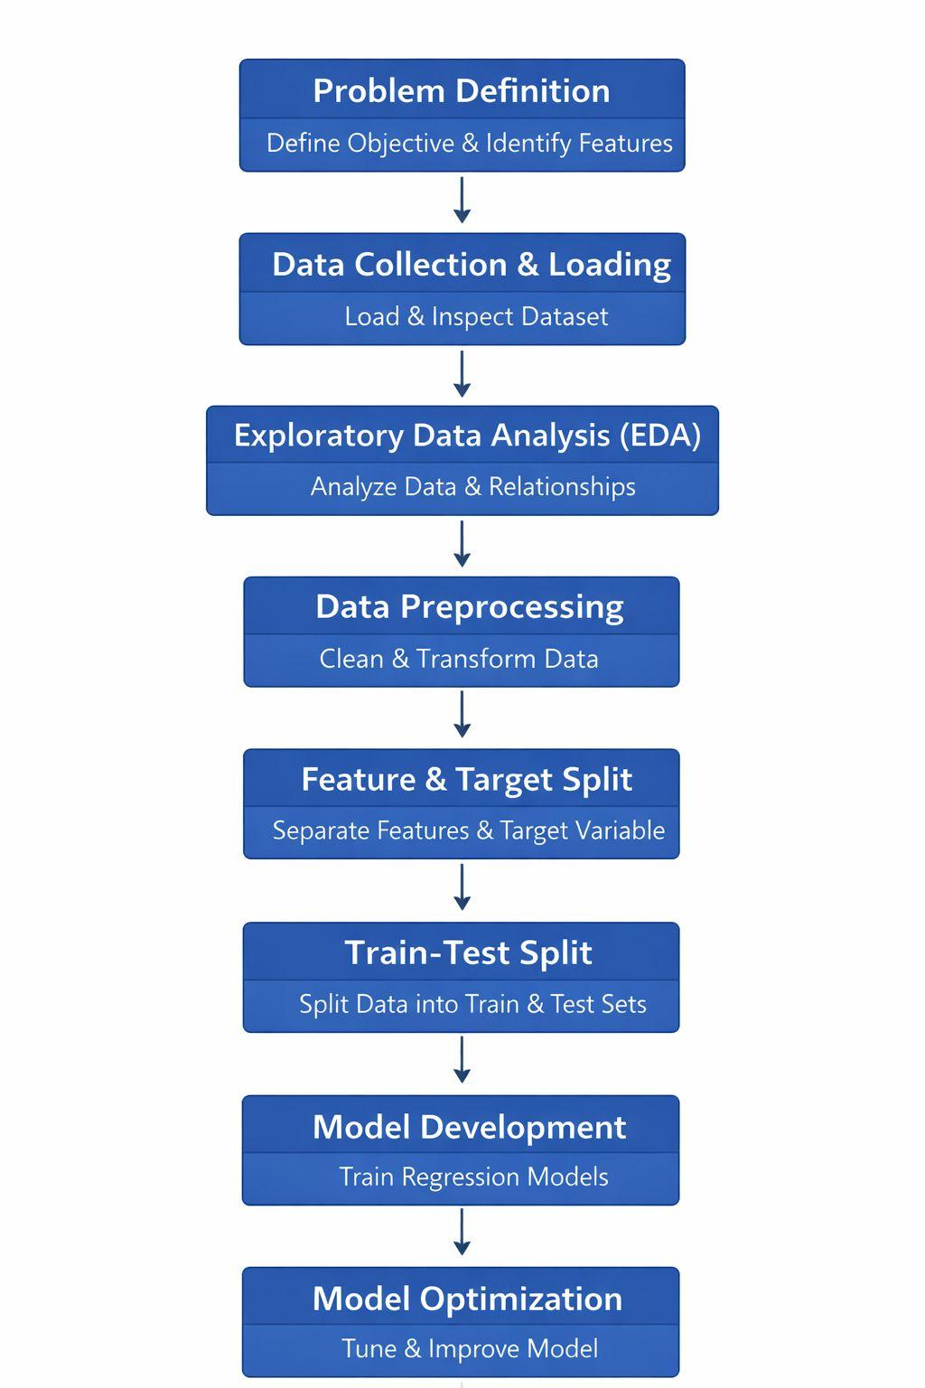
- Expected Modules/ Libraries to be used :
Core Data Manipulation
1. NumPy
NumPy is the foundational library for numerical computing in Python, centered around the powerful N-dimensional array object. It provides high-performance mathematical functions to operate on these arrays, making it much faster than standard Python lists. It’s the engine that powers most other data science libraries.
2. Pandas
Pandas is built on top of NumPy and introduces the DataFrame, a 2D table-like structure similar to an Excel spreadsheet. It is the go-to tool for data cleaning, manipulation, and analysis. It allows you to easily handle missing data, merge datasets, and filter information using intuitive labels.
Visualization Tools
3. Matplotlib
Matplotlib is the grandfather of Python visualization, offering a low-level interface for creating static, animated, and interactive plots. It gives you total control over every element of a figure, from line styles to axis labels. While powerful, it often requires more code to make things look good.
4. Seaborn
Seaborn is a high-level library built on Matplotlib that specializes in making beautiful, statistical graphics with less code. It integrates seamlessly with Pandas DataFrames and comes with built-in themes and color palettes. It excels at complex visualizations like heatmaps, violin plots, and time-series distributions.
Scikit-Learn (ML Workflow)
5. sklearn.preprocessing
This module is used to transform "raw" data into a format suitable for machine learning models. It includes tools for Scaling (making sure all numbers are on the same scale), Encoding (converting text labels into numbers), and handling outliers. Proper preprocessing often determines whether a model succeeds or fails.
6. sklearn.linear_model
This contains algorithms that assume a linear relationship between input variables and the target output. Its most famous members are Linear Regression (for predicting numbers) and Logistic Regression (for classification). These models are prized for being fast, easy to interpret, and highly efficient.
7. sklearn.model_selection
This module helps you organize how you train and test your AI. It includes functions like train_test_split to divide your data so you don't cheat by testing on what the model has already seen. It also features Cross-Validation and GridSearch to help find the best possible settings for your model.
8. sklearn.feature_selection
Not all data is useful; sometimes noise can confuse a model. This module provides techniques to select the most relevant variables (features) for your prediction. By removing redundant or irrelevant columns, you can reduce the complexity of your model, speed up training, and improve accuracy.
.
- Expected Evaluation metrics and Plots to be used:

1. Visualizations
Before building the model, visual diagnostics are used to ensure the data is clean and that our assumptions are grounded in reality.
- Boxplots (Risk & Anomaly Detection): These plots are used to identify statistical outliers. By isolating extreme values we can decide whether to include them in the general model or treat them as a separate feature.
- Scatter Plots (Variable Relationships): We use these to visualize the correlation between independent variables and the target (total_medals). This confirms whether a relationship is linear or requires a more complex mathematical approach to capture the trend accurately.
- Actual vs. Predicted Plots (Model Validation): This is the ultimate audit of the model. By plotting our predictions against the real historical values, we can visually confirm if the model is consistently accurate or if it tends to over-estimate or under-estimate in certain years or countries.

2. Quantitative Metrics
These metrics provide an objective "scorecard" to justify the model's accuracy before it is deployed for business use.
- R-Squared (R²):
A high R² indicates that the model has successfully learned the primary factors driving total medals.
- Mean Absolute Error (MAE): The Real-World Margin of Error
This is the most intuitive metric for medal prediction. It represents the average expected difference between our prediction and the actual difference in medals.
- Root Mean Squared Error (RMSE): The Risk Indicator
While MAE treats all errors equally, RMSE penalizes large misses more heavily. This is a critical safety metric; it ensures the model isn't making rare but massive errors that could lead to significant miscalculation.

- Required topics from the subject:

1. Exploratory Data Analysis (EDA) & Descriptive Statistics
Before any prediction can happen, the data must be cleaned. This is what your plots are doing.
- Outlier Theory: Knowing how to identify and handle statistical anomalies that can skew our prediction.
- Bivariate Analysis: The study of how two variables (like "athlete count" and "total medals") interact.

2. Feature Engineering & Data Pre-processing
This is the most critical part of the code—turning raw data into "machine-readable" intelligence.
- Categorical Encoding Strategies: Specifically One-Hot Encoding. This is the process of converting qualitative data (NOC ) into a matrix(1s and 0s).
- The Dummy Variable:
- Understanding why we used drop=True to prevent redundant data from confusing the model’s logic.
- Data Cleaning: Managing missing values and data type conversion

3. Predictive Analytics (Regression Modeling)
This domain covers the "AI" part of your project—the algorithms that learn from history to predict the future.
- Linear & Non-Linear Regression: Understanding the mathematical relationship between input features and the medals.
- Supervised Learning Workflow: The process of training a model on historical data so it can generalize to new, unseen country and their medal data.

4. Model Validation & Performance Diagnostics.
- Error Quantization (MAE, RMSE): The ability to translate mathematical variance into real-world prediction of medals.
- Variance Explanation (R²): Assessing the goodness of fit to determine if the model is actually capturing the the features and analysing thke or just memorizing noise (Overfitting).
- Bias-Variance Tradeoff: Finding the balance between a model that is too simple (underfitting) and one that is too complex (overfitting).

- Platform Required:
jupyter notebook
- Books and Link Sources:

Youtube link : https://youtu.be/Pwj9Hzq1m-E?si=MVTO2NJpFXciFChe
1. Kaggle : for downloading the Olympic and noc regions dataset
2. Chatgpt : For helping in understanding what to do and why we are doing it
3.​Pandas Official Documentation – https://pandas.pydata.org/docs/
4.​Scikit-learn Official Documentation- https://scikit-learn.org/docs/

